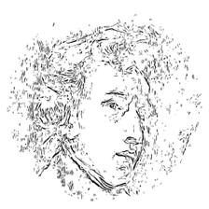

2025 Nashville International

Chopin Piano Competition

TBILISI LIVE AUDITION APPLICATION

Application information

Full name: |  |  |  |  |  |  |  |  |  | Date:
 |  | Last | First |  |  |  | M.I.
Address: |  |  |  |  |  |  |  |  |  | Phone:
 |  | Street address |  |  |  |  | Apt/Unit #
 |  |  |  |  |  |  |  |  |  | Email:
 |  | City |  |  |  | State | Zip Code
Nationality
Competition Category |  |  |  |  | Young Musician I (age 5 – 10) ☐ |  |  | Young Musician II (age 11 – 15) ☐ |  |  | Artist  (age 16 – 33) ☐

Education

High school: |  |  |  |  |  | Dates:
College: |  |  |  |  |  | Dates:
Teacher: |  |  |  |  |  | Email:

Repertoire
Young Musician I (ages 5 - 10): 10 minutes; Young Musician II (ages 11 - 15): 15 minutes; Artist (ages 16 - 33): 20 minutes; all auditions must include work by Chopin and a fast etude in the Artist Category.

Composer: |  |  |  | Work:

Application Fee
Please complete payment in the amount of $50 USD by PayPal using the QR code below or at tinyurl.com/TbilisiAudition
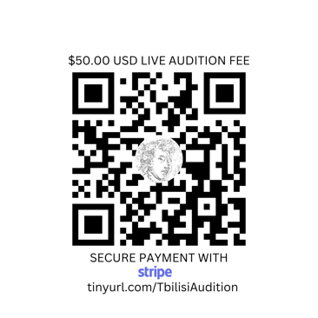
SCAN QR CODE TO PAY APPLICATION FEE
Signature ___________________________

Date ___________________________

